______________________________________________________________________
Issuing Office: Vice Chancellor Policy Number: FY13-A&F-004-02
for Administration and Finance
______________________________________________________________________

Policy Name: UMass Boston Alert System

Original Date Issued: April 24, 2013
Revision #: 4
Last Update: May 1, 2019

Purpose of Policy: This policy establishes the guidelines by which the UMass Boston Alert System will be used for distribution of emergency alerts. This system is also referred to as the ENS (Emergency Notification System.) This policy complies with the Department of Education requirements regarding timely notice of certain events as described 20 U.S.C. s. 1092(f), known as the Jeanne Clery Disclosure of Campus Security Policy (The Clery Act), along with the Campus Crimes Statistics Act (1998) and the Higher Education Reauthorization Act (2008).

Applicable to: All departments at UMass Boston.
Policy: All reports of fire or explosion should be made immediately by calling 911. To report other emergencies, dial 911 from a campus phone or 617-287-1212 from a cell phone to reach UMass Boston Police Dispatch. A reminder of this important reporting of an emergency will be issued annually by the UMass Boston Police Department.

The University of Massachusetts Boston has an emergency notification system in place to provide timely information and direction to students, faculty, staff, visitors, and other members of the campus community (hereafter referred to as “the campus community”). Upon confirmation of a significant emergency or dangerous situation involving imminent or immediate threat to the health or safety of the campus community, occurring on or immediately adjacent to the campus (hereafter referred to as “confirmed threat to the campus community”), emergency notifications will be sent without delay via the UMass Boston Alert System.

The decision to issue an alert without delay, shall be decided by the Assistant Vice Chancellor for Facilities Management for facilities-related incidents; the Chief of Police for all public safety issues, criminal incidents and campus-wide evacuations; the Director of Environmental Health and Safety for hazardous materials incidents; or the Emergency Manager for severe weather incidents. Decisions are made on a case-by-case basis, in light of all the facts surrounding an incident or crime, including factors such as the nature of the incident/crime, the immediate or continuing threat to the campus community, and the possible risk of compromising law enforcement efforts.

The system has the capability to send alerts via email, text, voice, digital signage, PC desktop alerts (where available), external speakers, social media (official UMass Boston Twitter and Facebook accounts), and the UMass Boston Smartphone Application.

Alerts sent to signal university closure due to a severe weather emergency will be sent by the Office of Communications as text messages, email and social media only. Severe weather closing information is also posted on the university website, main telephone line, UMass Boston Smartphone Application, and via local news media.

Authority to Send Messages:
- The Assistant Vice Chancellor for Facilities Management/designee, Chief of Police/designee, Director of Environmental Health and Safety/designee, or Emergency Manager/designee may request an immediate initial alert be sent by UMB PD Dispatch if there is a “confirmed threat to the campus community.” The authority of each office to trigger an alert is limited to the area overseen by each respective office.
Position | Type of Emergency Authorized to Alert
AVC Facilities Mgt. | Confirmed facilities emergency causing immediate threat to the campus community.
Chief of Police | Confirmed public safety threat to the campus community.
Director of EHS | Confirmed hazmat emergency causing immediate threat to the campus community.
Emergency Manager | Confirmed weather emergency causing immediate threat to the campus community. (Not routine weather closing messages sent by Communications.)
- Departments authorized to request initial alerts may request alerts only for their particular area as noted above. Departments must review and approve available alert templates on an annual basis.
- Following the initial alert, Communications sends all follow up alerts and “all-clear” messages.
- If there is a confirmed threat to the campus community, an initial emergency alert will be sent without delay via email, text, voice, digital signage, PC desktop alerts, social media, and smartphone application. External speakers should be activated as appropriate. UMass Boston Police maintains clear protocols for individuals authorized to send messages to avoid delay.

- Office of Communications
Alerts sent as follow-up messages to a “confirmed threat to the campus community” are issued by the Office of Communications via email, text, voice, digital signage, PC desktop alerts, social media. This office may also send an initial alert for campus closures due to inclement weather or utility outages.

- Other
There are specific lists within the system available to campus and department leadership personnel to notify smaller groups as appropriate. List administrators will have access to specific department lists, as approved.

Procedures:
Access to the system is managed by the Office of Emergency Management and Business Continuity. A list of staff trained and authorized to send mass-notification alerts is posted in the UMass Boston Police Dispatch area and Administration and Finance. Positions trained include Director of Communications, Communications staff, Emergency Manager and all UMass Boston Police Officers.
Alerts:
When there is a “confirmed threat to the campus community”, Assistant Vice Chancellor for Facilities Management, Chief of Police, Director of Environmental Health and Safety, or Emergency Manager will direct UMass Boston Police Dispatch to send an emergency alert, according to the specific procedures articulated in the Alert System Training Document. (This document is limited to staff trained in sending alerts.) The initial alert will be sent using one of the pre-scripted template messages stored in the Alert System.
Following the issuance of the emergency alert, the Chief of Police or designee shall notify the Chancellor’s Chief of Staff, Vice Chancellor for Administration and Finance and the Vice Chancellor for Student Affairs of the circumstances necessitating the alert.

Follow-up alerts may be issued by the Office of Communications, in coordination with UMB PD and will be posted on the university homepage.

Training:
The Chief of Police or designee and Director of Communications shall designate individual staff members to receive UMass Boston Alert System training provided by the Emergency Manager. Refresher training and drills shall occur each semester and when new technologies require additional training. These regularly scheduled trainings of personnel shall be documented by the Emergency Manager. The Chief of Police will mandate regular training of UMass Boston Police Staff conducted by the Emergency Manager.

Testing/Maintenance:

The system shall be maintained by testing and verification through the Office of Emergency Management and Business Continuity, and IT. There shall be at least one scheduled test during each quarter. During each alert system test, Emergency Management, UMB PD, and One Card Services will test the University Hall Lockdown Button System. Each test and follow-up will be documented in accordance with the Clery Act.

Definitions:
- ENS – RAVE- UMass Boston Alert System
UMass Boston’s Emergency Notification System (ENS), contracted from Rave Wireless and integrated with the outdoor speaker system provided by Acoustic Technologies is hereafter known as the “UMass Boston Alert System”. The system is capable of issuing emergency alerts by text, email, voice, outdoor loudspeaker, digital signage, and via social media.
- Emergency Alert
An emergency alert is an urgent communication warning upon confirmation of a significant emergency or dangerous situations involving imminent or immediate threat to the health or safety of students or staff occurring on or immediately adjacent to the campus (hereafter referred to as “confirmed threat to the campus community”). Emergency alerts are sent via the UMass Boston Alert System. An example of a threat requiring an emergency alert would be an active shooter or hurricane/tornado warning. Weather emergencies that warrant cancellation of classes and events will be signaled by text messages and social media.
- Broadcast Emails
When conditions do not warrant the issuance of an emergency alert, the University may send information in the form of a Broadcast Email. Email broadcasts may be sent either through the University Outlook email system or as UMass Boston Alert System emails.
- Timely Warnings
Timely Warnings are notices to the community that a crime named by the Clery Act has been committed on or around campus. The Jeanne Clery Disclosure of Campus Security Policy and Campus Crime Statistics Act (20 USC § 1092(f)) is the landmark federal law, originally known as the Campus Security Act, that requires colleges and universities across the United States to disclose information about crime on and around their campuses. The Act is enforced by the United States Department of Education. Timely Warnings, under the Clery Act, will be sent as email broadcasts, and may be sent in conjunction with a text message.
- Shelter in Place
There may be a need to advise the community to shelter in place via text alert. If you are told to shelter in place, seek shelter inside a building and remain inside until the danger passes. Shelter in place is used when evacuating a building would cause greater risk than staying where you are. Shelter in place is the best approach for certain chemical releases were the doors and windows are closed and the ventilation, heating and cooling systems are shut down. During high winds or tornadoes, it’s often safest inside a solid building where you can stay away from windows. In place protection can also be the best approach if there is an active shooting situation outside especially if you can lock your building. Officials will continue to gather information and announce when the threat is removed.

- University Hall Lockdown Button System

University Hall has a classroom emergency lockdown button system. These buttons when pushed, lock the door to the room in which you are located from the outside. The button also triggers a silent alarm that instantly notifies UMass Boston Police of a threat situation at the location where the button was pushed.

Oversight Department: Vice Chancellor for Administration and Finance
Responsible Party within Department: Emergency Manager

Monitoring: Quarterly reports, including participation levels, training, and test results to Chancellor’s Cabinet and the Director of Communications.

Authority: Clery Act, DOC. T99-060, Passed by the UMass BOT 8/4/99, revised 12/14/11. University of Massachusetts Emergency Management and Business Continuity and Planning Policy

Related Documents:
- Quarterly Report Format
- Pre-scripted Emergency Alerts

SAMPLE: UMass Boston Alert System Quarterly Report
For the Period 9/2018 – 12/2018

1. System Enrollment
New users during this period 2,142 65.81% of all enrolled have input at least one mobile
contact
2. Activations:
10/01/18 12:00 PM Everyone Campuswide Alert Test 21,616 Completed
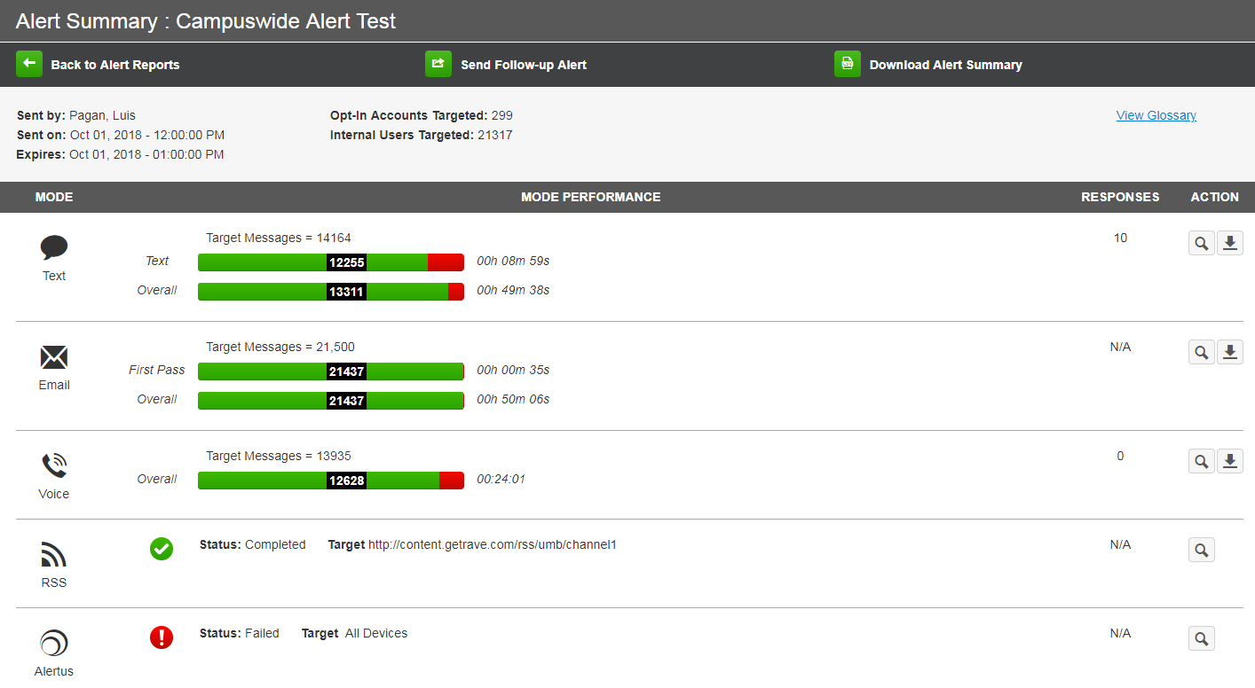
3. Performance Summary

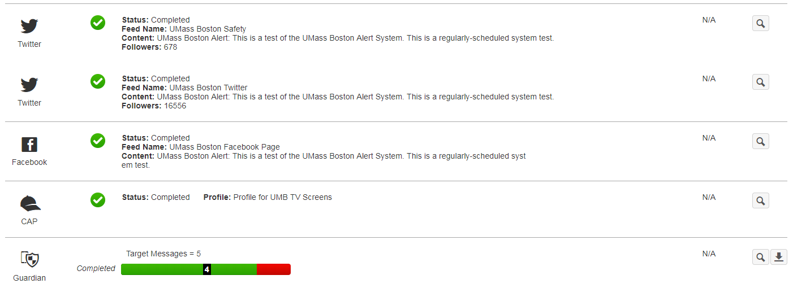

Sample: ENS Template Emergency Messages – 2/13/19
*Alerts listed are an example of a by building/parking lot alert. These alerts have a template for every UMB building, parking lot, and also includes neighboring sites like EMKI, JFK, Archives, and BC High.

ALL CLEAR – GENERAL
UMass Boston Alert: All Clear. The previous alert has been cancelled. See the UMass Boston website for further information.

ACTIVE SHOOTER – Campus Center*
UMass Boston Alert: Gun shots reported in the Campus Center. Avoid area. Emergency personnel responding.

BOMB THREAT – Campus Center*
UMass Boston Alert: Unconfirmed Bomb Threat reported in Campus Center. Evacuate Campus Center and stay clear of area until further notice.

BOMB THREAT - GENERAL
UMass Boston Alert: Unconfirmed Bomb Threat to campus. Evacuate campus in an orderly fashion.

BOMB THREAT - ALL CLEAR
UMass Boston Alert: Bomb Threat all clear. No device was found.

CAMPUSWIDE ALERT TEST
UMass Boston Alert: This is a test of the UMass Boston Alert System. In an emergency, this alert would contain pertinent information. This is only a test.

CAMPUSWIDE Evacuation (Standard)
UMass Boston Alert: Campus-wide evacuation. Leave campus immediately following instruction from public safety. More info to follow.

CAMPUSWIDE Evacuation (Walking)
UMass Boston Alert: Evacuate campus immediately. Quickly begin a non-vehicular evacuation off campus grounds. More info to follow.

Facilities Incident- Campus Center*
UMass Boston Alert: Facilities incident in/near Campus Center. Avoid area. More information to come.

Fire- Campus Center*
UMass Boston Alert: The Campus Center has been evacuated for a fire. Avoid area. Officials are on scene.

HAZMAT INCIDENT- Campus Center*
UMass Boston Alert: Hazardous Materials reported in the Campus Center. Evacuate building. Avoid area.

HAZMAT INCIDENT- ALL CLEAR
UMass Boston Alert: Hazardous materials incident resolved. No release of chemicals; no injuries. All clear.

HURRICANE CLOSING
UMass Boston Alert: Due to Hurricane, the campus is closed. All activities and classes are canceled. Check www.umb.edu for updates.

Police Incident- Campus Center*
UMass Boston Alert: Police incident in/near Campus Center. Avoid area. More information to come.

Public Safety Threat – Campus Center*
UMass Boston Alert: Public Safety threat in/near Campus Center. Avoid area. More information to come.

TORNADO WARNING
UMass Boston Alert: Tornado Warning. Seek shelter indoors, away from windows. Wait for all clear signal.

TORNADO - ALL CLEAR
UMass Boston Alert: Tornado Warning lifted. All clear. Resume normal activities.
WEATHER CLOSING
UMass Boston Alert: Weather Emergency -- The University is closed “February 5”. Classes and activities are cancelled. See www.umb.edu for more information.

WEATHER DELAYED OPENING
UMass Boston Alert: Weather Emergency -- Delayed opening. The university will open at 11 a.m.

WEATHER EARLY CLOSING
UMass Boston Alert--Weather Emergency. Early Closing. The university will close as of 3 p.m. All afternoon and evening classes cancelled.

